11th practical:

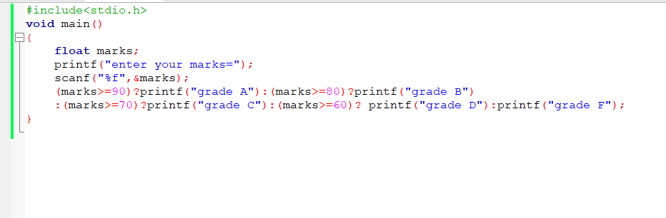

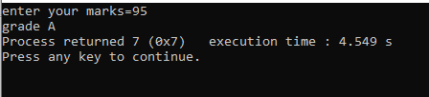

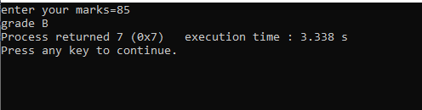

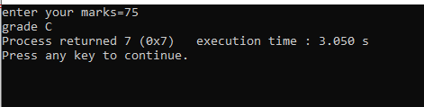

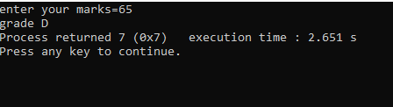

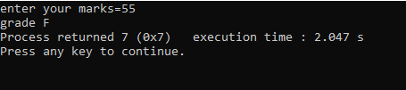

11th-1:

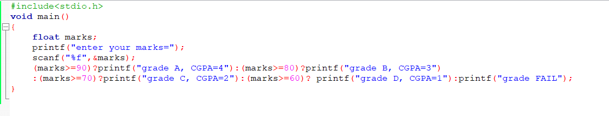

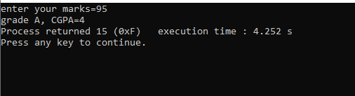

11TH-2:

